# MAT 243 Project One Summary Report

[Alex Roberts]

[alexander.roberts1@snhu.edu]

Southern New Hampshire University

## Introduction: Problem Statement

* The problem that we are trying to solve is using historical data to track past stats for a selected team that the coach of the team can use this data to increase the performance of the team in future games. I am using the Python language in codio to get this data.

## Introduction: Your Team and the Assigned Team

Table 1. Information on the Teams

|  | **Name of Team** | **Assigned Years** |
| --- | --- | --- |
| 1. Yours | Wizards | 2013-2015 |
| 2. Assigned | Bulls | 1996-1988 |

## Data Visualization: Points Scored by Your Team

Data visualizations are good for tracking and comparing data by giving you a more visual look at the data which can sometimes be easier to understand than reading it in words.

* 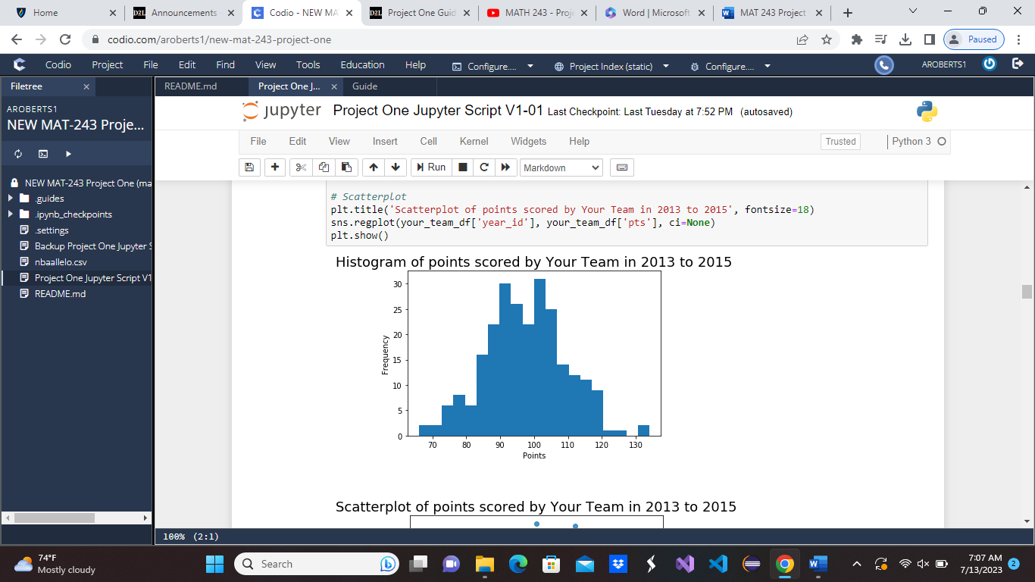
* I chose this plot because I find it easier to read and I feel like it shows a better comparison to the scores made during the range of years. From the diagram it looks like they scored around 95 and 105 most often in between these years.

## Data Visualization: Points Scored by the Assigned Team

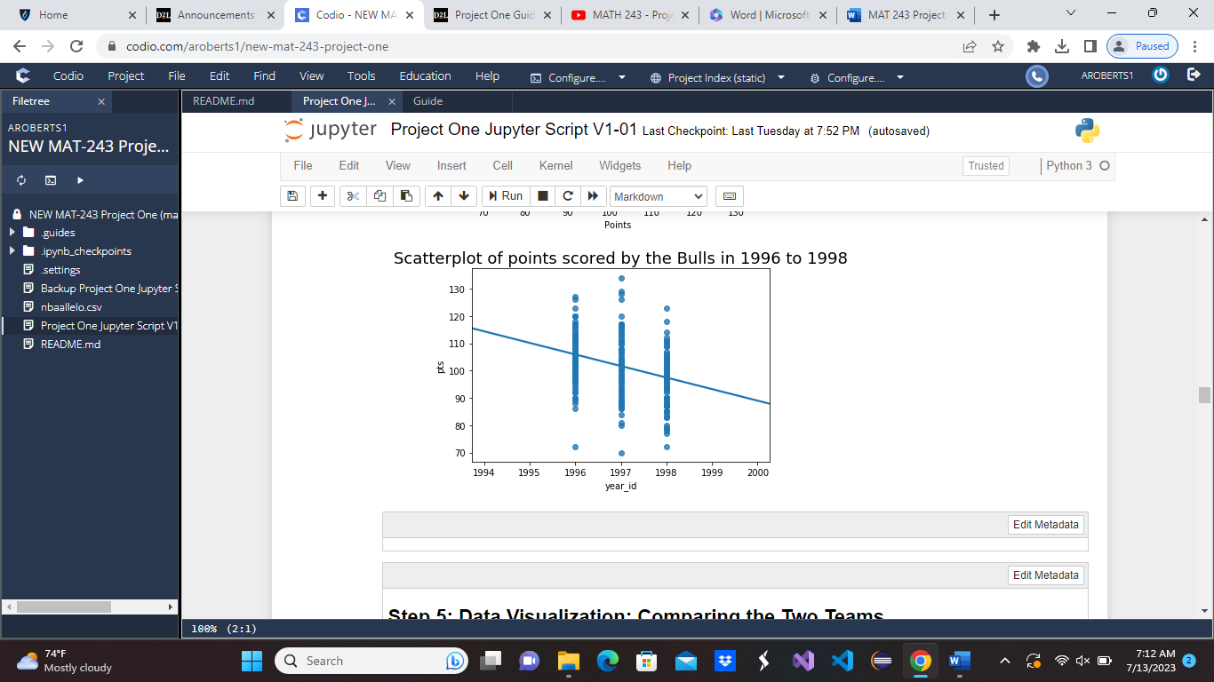

I chose this plot because I feel like it more accurately depicts the points scored within the range of the years provided. According to the plot it looks like the Bulls scored the most points in 1997 since the points are at the highest on the chart at over 130. The years before and after are still good but they were thriving in 1997.

## Data Visualization: Comparing the Two Teams

Plots can be used to compare two different results by giving you a visualization of the data that can be easier to understand than reading it in words. It physically shows you the comparison.

* 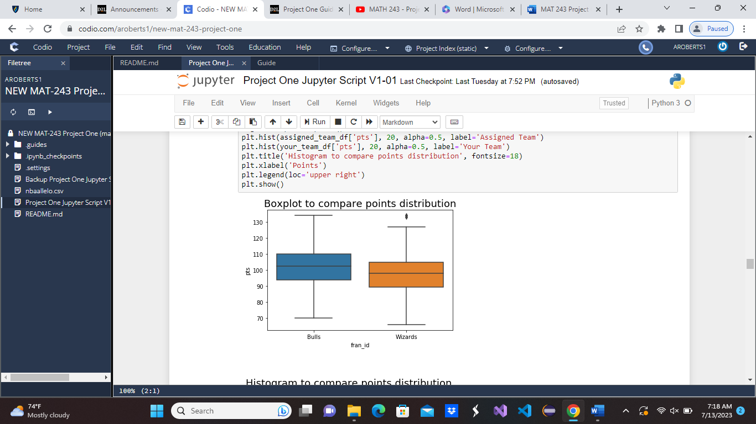
* I chose this plot because I feel like it is easier to read and understand than the histogram. Although both are great ways to perform the comparison, I feel the histogram is a little more clustered and could be more confusing. Maybe not for everybody, but in some cases. It appears, according to the visualization, that in the years of 1996-1998 the Bulls scored more points than the Wizards did in the year 2013-2015.

## Descriptive Statistics: Points Scored By Your Team in Home Games

| **-** | **Value** |
| --- | --- |
| *Mean*  *Median*  *Variance*  *Standard Deviation* | *100.18*  *101.0*  *116.07*  *10.77* |

In general, these descriptive stats can be used to show the difference of the points scored in the range of years by giving us a view of the differences. The mean is the average of points in the range of years. The median is the middle value of the points scored. The variance is the difference of the range of data. The standard deviation is the square root of the variation. The skew is right as the numbers are increasing (positive).

## Descriptive Statistics: Points Scored By Your Team in Away Games

| **Statistic Name** | **Value** |
| --- | --- |
| Mean  Median  Variance  Standard Deviation | *94.76*  *95.0*  *147.98*  *12.16* |

The mean is showing the average of all of the scores within the years of range. The median is showing the score in the middle of the data range. The variance is showing the differences between the highest and lowest points of the data. The standard deviation is showing the differences between the data points. This is aslo skewed right as the scores are increasing. The team is not scoring better at away games which means in this range of years they were performing better at home games.

## Confidence Intervals for the Average Relative Skill of All Teams in Your Team’s Years

| **Confidence Level (%)** | **Confidence Interval** |
| --- | --- |
| 95% | (1502.02, 1507.18) |

The confidence interval is showing the average relative skill in the range of years and the probability of how they will do in future games. According to this confidence interval it is depicting that they will have a higher average relative skill based off of these statistics.

## Confidence Intervals for the Average Relative Skill of All Teams in the Assigned Team’s Years

| **Confidence Level (%)** | **Confidence Interval** |
| --- | --- |
| 95% | ( 1487.66 , 1493.65 ) |

The confidence interval is showing the average relative skill in the range of years and the probability of how they will do in future games. According to this confidence interval it is depicting that they will have a higher average relative skill based off of these statistics.

## Conclusion

In conclusion, The data shows that the Bulls performed better in the years 1996-1998 than the wizards did in 2013-2015. Both teams are projected to have better performance in future games. The wizards perform better at home games than they do at away games. In general, it seems that the bulls have a higher range of scores than the Wizards do and they both show promise to perform better in the future.